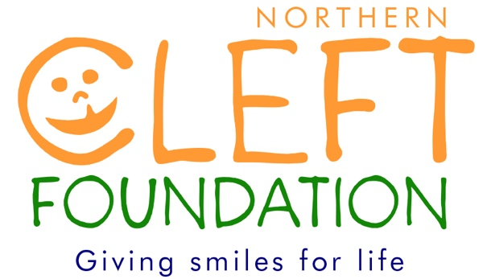
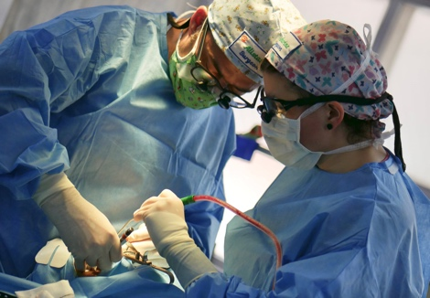

Using a BAOMS Travel Grant with The Northern Cleft Foundation
– Catherine Wicks, Specialty Registrar, University Hospitals Bristol

Introduction

In January 2019, I had the privilege to travel to Nagpur, India with the Northern Cleft Foundation. This well established charity, set up in 2001 by Consultant Anaesthetist George Teturswamy, organises yearly outreach trips with a team of 8 UK Consultant Cleft Surgeons and 10 Consultant Paediatric Anaesthetists. The aim is to provide comprehensive cleft lip and palate surgery and care to those otherwise unable to afford treatment in the state of Maharashtra, India. The outreach has travelled to multiple locations in India but has been based at the Mure Hospital in Nagpur for over 10 years.

The Nagpur Rotary club is the main charity which provides funding locally. They provide food and travel for all the families in hospital and all the surgical team daily during the outreach. The local Rotarian doctors are vital in locating patients to attend the outreach annually. They arrange the pre-operative assessments, including haematology and biochemistry. These are vital, as 78% of children in Nagpur are anaemic and 45% are underweight. All patients are seen in pre-operative clinic with UK consultant cleft surgeons, anaesthetists and speech and language therapists. If they are assessed to be unfit for this outreach, they are optimised for surgical intervention the following year with advice surrounding feeding and nutrition provided by specialist cleft nurses. If a congenital anomaly is suspected, the child is funded by the charity to attend the local paediatric hospital for their care. They will then return to have their primary lip and palate repaired at a subsequent outreach.

Patients are listed on a computer system and full medical records are kept during the period of hospital admission. This allows continuity of care so that patients who receive lip repair are subsequently invited to return the following year for palate repair. The team can provide speech therapy and secondary surgery for fistula, velopharyngeal insufficiency, cleft lip revision and septorhinoplasty. This year a link was established with the local Government Dental College and Hospital at Maharashtra University, with hopeful intentions to provide patients with alveolar bone grafting and orthodontics in the future.

The surgical outreach spanned across six days of operating, with pre-operative assessment clinics running daily alongside. Post-operative ward care continues until all patients are fit for discharge. Resident on call overnight was provided by anaesthetic and surgical registrars. A total of 83 operations were performed across five theatres with six UK consultant cleft surgeons. Our team included all the usual team members that would be expected in an efficient NHS service: specialist ward nurses, recovery staff, anaesthetists, surgeons, scrub practitioners, ODAs, ward doctors, speech therapists, runners, decontamination staff and a senior theatre co-ordinator. We also had a brilliant group of volunteers who took on the role of porters, cleaners and play therapists on the ward, entertaining the children with a wealth of donated games and toys.

My Experience

I found the outreach to be a fantastic personal experience. The surgical exposure I was fortunate enough to have was extensive. I was involved with 16 cleft operations including primary unilateral and bilateral lip repairs (see photos left), primary and secondary speech surgery, fistula revisions, lip revisions, alveolar bone grafting and a pre-maxillary osteotomy. More rare cases such as lateral clefts were also seen and operated on.

I worked with 5 different UK Cleft consultants, a privilege not usually feasible, even within a TIG fellowship. The volume and increased prevalence of bilateral clefts also meant I encountered far more cases than one might expect to see even over the course of a year in a standard UK cleft unit. I also found the intense exposure hugely helpful in solidifying both surgical and treatment planning concepts. There is no substitute for seeing a surgical technique first hand to gain full understanding. Therefore, from the perspective of logbook numbers, I have achieved all minimum requirements for CCT in 6 days alone. The overall experience of working within such an incredibly committed team, with inspiring people, was far more important and valuable than any logbook however. I would recommend this brilliant outreach to anyone, and anyone can volunteer; surgical and anaesthetic registrars, SLTs, Cleft specialist nurses, ward and recovery nurses, ODPs/ODAs, and medical and dental students.

Application and Funding

To volunteer for this brilliant experience, application is via a form which can be found on the charity’s website: http://www.northerncleftfoundation.co.uk/ If accepted as a volunteer, travel/accommodation costs are £1500 plus visa fees. This can either be funded personally, via fundraising efforts or a BAOMS travel bursary can be applied for, which is what I was lucky enough to be granted.

BAOMS members can apply for this funding via an online form on the website: https://www.baoms.org.uk/professionals/baoms_grants.aspx Payment is then provided once a report of the intended activity is provided.

